
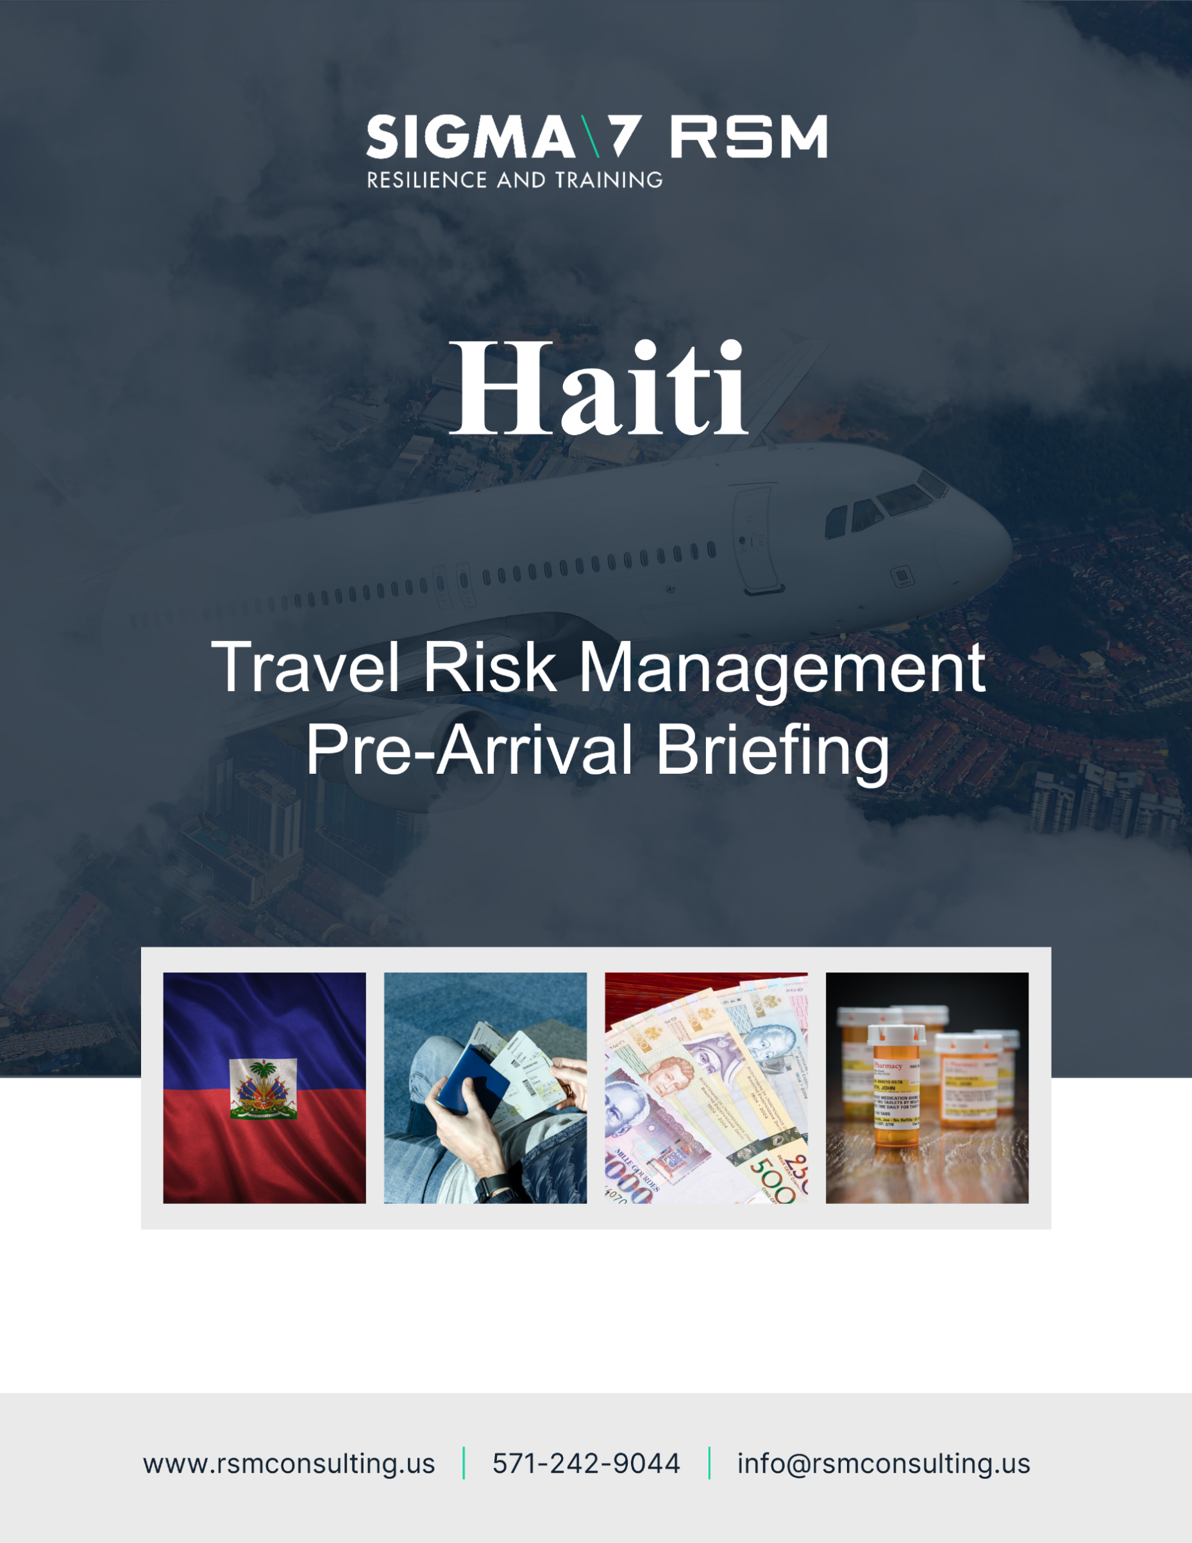
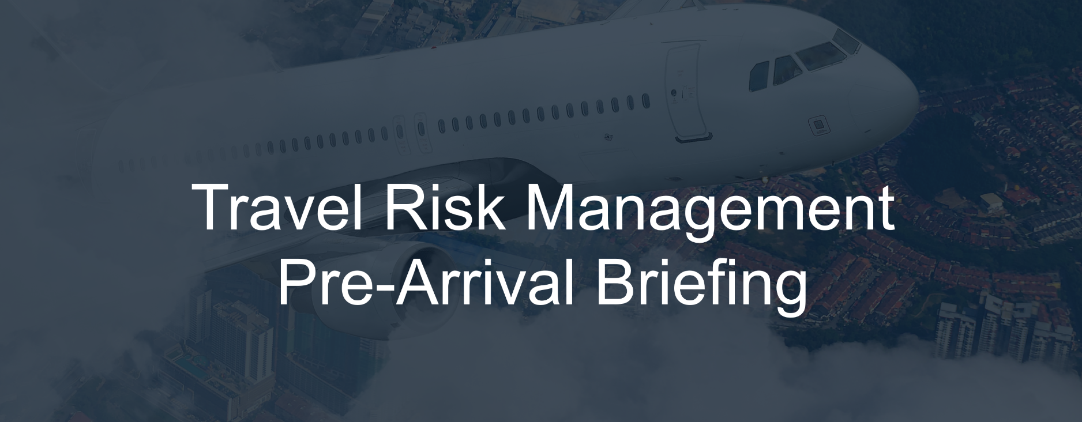
Ecuador
Welcome to Ecuador
The following Pre-Arrival Safety, Security and Cultural Briefing will be sent to international travelers 14 days ahead of their arrival or will be made available through standing [electronic] travel risk management systems. This briefing provides safety, security and cultural advice for this country, as well as useful points of contact. Travelers should proactively request information as needed.

The details of any ‘Meet and Greet’ personnel will be reconfirmed at least 24hrs ahead of your departure date by your host, including [ideally] the photograph, name and mobile phone number of the person collecting you. The traveler collection area or pick- up area will include a sign with “Project Name” for positive identification, if applicable.
It is the traveler’s responsibility to:
- Have an up-to-date copy of this briefing document in time for travel.
- Reach out to the in-country team for safety and security advice.
- Seek medical advice for the country to be visited [ahead of travel] through AIG portal: https://travelguard.secure.force.com/TravelAssistance/TGRegister?PL=AIGACCIDENTANDHEALTH and be fully fit to travel.
- Ensure you have up to date inoculations as well as the appropriate paperwork.
- Have the correct visas and travel documents.
- Attend the required briefings and training, well in advance of travel.
- Notify the appropriate stakeholders of the travel plan.
- Enroll in the Smart Traveler Enrollment Program (https://step.state.gov/step/) to receive Alerts and make it easier to locate you in an emergency.
- Conduct research on the country; its culture, social norms, history and safety and security issues.
- Have the correct prescription medicines [including spares].
- Have the ability to communicate during travel [mobile international roaming and VIOP] or purchase in-country SIM card and mobile phone or AIRALO apps.
  - Non (+1) phone numbers should be re-started on a daily basis.
- Keep emergency phone numbers registered on speed dial – and retained in a printed format.
- Notify personal bank or credit card company of the trip so your card is not deactivated.
- Carry printed copies of the passport and a digital photocopy and other documents [in case of loss].
- Carry essential equipment/supplies/medication within hand luggage/carry on.
- Have approx. $500 in emergency cash.
- Request a security and safety briefing before arrival.
- Notify the in-country team, and headquarters team, of any concerns or incidents immediately.
You should ensure that you take the time to prepare well in advance of your trip and seek advice and guidance in a timely manner.

Communications
The following points of contact will be associated with your visit. You are requested to save these on your phone and on your computer. A printed copy should be placed within your wallet or purse:

Main Point of Contact (Trip Coordinator)
Name: | Insert here
Email: | Insert here
Phone: | Insert here

Safety and Security Point of Contact (COP???)
Name: | Insert here
Email: | Insert here
Phone: | Insert here

Emergency Point of Contact
Name: | Insert here
Email: | Insert here
Phone: | Insert here


Embassy Emergency Point of Contact
Name: | U.S. Embassy Quito
Email: | ACSQuito@state.gov
Phone: | 593-2-398-5000  Emergency numbers: 593-2-398-5000 or 593-9-9788-3222
Phone: | The following number can be used to locate your nearest embassy: +1 202 501 4444

Local Medical Emergency Point of Contact
Name: | Insert here
Email: | Insert here
Phone: | Insert here

Insurance Details
Provider: | AIG Travel Guard
Policy No: | 9158541
Phone: | 1-877-244-6871

Please ensure you provide the following details to your trip coordinator:
- Your flight and hotel details.
- Your mobile phone number (please ensure it is switched to international roaming).
- Any VOIP details (such as WhatsApp and/or Signal).
- Any medicines or medical details we should be aware of.
- You next of kin details.
Registrations

You are recommended to register your trip with your embassy. For US citizens you should register under the Smart Traveler Enrollment Program (STEP) found at: https://step.state.gov/step/
Insurances

It is your responsibility to ensure all insurances (and copies of insurances) are complete before you travel. You should have electronic and printed copies of this information with you.

Information Sources

Information sites include some of the following websites:

- U.S. Embassy in Quito https://ec.usembassy.gov/
- U.S. Consulate General in Guayaquil https://ec.usembassy.gov/embassy-consulate/guayaquil/
- The US government (or your own) embassy website on safety and security topics for this country, including through: https://travel.state.gov/content/travel/en.html
- The CIA Fact Book on: https://www.cia.gov/library/publications/the-world-factbook/.
- The U.S Center for Disease Control [CDC] at http://wwwnc.cdc.gov/travel/ and the World Health Organization [WHO] at http://www.who.int/countries/en/ for health and vaccination information.
- Subscribing to alert services at AIG: https://travelguard.secure.force.com/TravelAssistance/TGRegister?PL=AIGACCIDENTANDHEALTH
- Federal Aviation Administration airport security information at www.FAA.gov.
- Hospital options: http://www.worldhospitalsearch.org.
- National Hurricane Center: http://www.nhc.noaa.gov/

Safety and Health Advice
Ambulance services are not present throughout the country and unreliable in most areas, except Quito, and not equipped with state-of-the-art medical equipment. Injured or seriously ill travelers may prefer to take a taxi or private vehicle to the nearest major hospital rather than wait for an ambulance, particularly outside of Quito. Adequate medical and dental care is available in major cities. In smaller communities and in the Galapagos Islands, services are limited, and the quality is generally well below U.S. standards.
Pharmacies are widely available. However, some medications might not be offered, and brand names will differ from products in the United States. Not all pharmacies purchase medications from pharmaceutical companies that adhere to quality control standards. You should ensure you are medically and dentally fit before you start your travels, carrying sufficient spare prescription medicines should your trip be unexpectedly extended.
Quito is 9,400 feet above sea level. Some other tourist destinations in the mountainous region may be higher. Consult your doctor for recommendations concerning medication and lifestyle tips at high altitude.


Inoculations
The following inoculations are recommended for your trip:
- The yellow fever vaccine is mandatory if coming from an endemic country (this is not the case for the United States). However, this vaccine is recommended for travelers who plan to visit the Amazon region.
- Other recommended vaccines for traveling to Ecuador include tetanus, hepatitis A, hepatitis B, MMR (measles, mumps, and rubella), and typhoid fever, among others. It is advisable to consult with a healthcare professional.
- The most common tropical diseases in Ecuador are dengue, malaria, yellow fever, chikungunya, and Zika virus. Although they are not usually fatal, they pose a serious risk to individuals with weakened immune systems, pregnant women, children, or the elderly.
- To curb the dengue outbreak affecting the provinces of Manabí, Santo Domingo de los Tsáchilas, Los Ríos, El Oro, and Guayas, the Ministry of Public Health of Ecuador recommends avoiding areas with stagnant water, using mosquito repellent, and wearing clothing that covers most of the body. It is very important that if you experience symptoms of dengue, such as fever, headache, skin rashes, muscle and joint pain, you go to the nearest health center and avoid self-medication.


Medical
The following general medical advice is provided for this country:
- Ensure you carry on your person your medical insurance details and emergency contact details, and ensure a copy of these is logged with someone reliable in-country. Important Note: Unless it is a life-threatening situation you must contact your medical insurance provider who will inform you of which medical facility you should use.
- It is recommended to bring at least 1 months’ worth of additional prescription medicines with you to cover any loss or unexpected extension of deployment. A copy of the prescription should be brought and all medicines should be kept in the original packaging.
- Spare and additional prescription glasses or contact lenses and appropriate cleaning fluid, is recommended along with a copy of the prescription information should replacements be required.
- Normal medical facilities are very limited and offer a poor standard of care.

Natural Hazards
Ecuador is a country with high seismic activity and volcanoes in various eruptive stages. It is advisable to stay informed about possible earthquakes or volcanic eruptions through the Geophysical Institute of Ecuador (www.igepn.edu.ec), and about tsunamis through the Navy Oceanographic Institute (www.inocar.mil.ec). In the event of a natural disaster, follow the recommendations of local authorities, particularly from the Risk Management Secretariat (https://www.gestionderiesgos.gob.ec/niveles-de-alertas-y-declaratorias-vigentes-establecidas-por-la-sgr/).
Transportation
Ecuador has an extensive bus network, primarily in major cities like Quito and Guayaquil, covering almost all destinations and making it the most economical means of transportation. However, thefts are frequent on public transport. Therefore, it is advisable to use official taxis.
Official taxis in Ecuador are yellow, have a "TAXI" sign, and usually display a taxi license number on both the outside and inside of the vehicle. Additionally, their license plates are orange, which distinguishes them from unauthorized or pirate taxis. Unlicensed taxis should be avoided to prevent kidnappings and robberies.
It's recommended to negotiate the fare before starting the ride to avoid any disputes later. You can ask locals for an idea of the typical fare to your destination. Some tourists encounter taxi drivers who pretend not to understand the address provided and try to charge more than the agreed-upon fare. Although official taxis are safe, one way to avoid such situations is by using taxi-hailing apps like Uber, Easy Taxi and Cabify. This apps provide a secure way to book a taxi with fixed fares and real-time GPS.
- XXXXX

Arrival Protocols
It is your responsibility to ensure you understand, and confirm, the arrival protocols for your trip, liaising with your in-country host. The following arrival protocols are to be applied:
- Confirm and share your travel schedule and internal country plans with XXXXX.
- Contact the trip coordinator appointed to manage your travel with questions.
- Ensure you receive the name, photograph and phone number of the person collecting you.
- Ensure you wait in the arrivals area upon arrival to be collected.
- If not met initially at the airport, do NOT leave the airport – ring the person collecting you – then ring your other in-country points of contact and remain inside the airport security area.
- When transiting in country notify your host of changes to your schedule.
- Travelers must declare currency in amounts greater than $10,000.

Security Advice
On January 2, the Executive Decree No. 493 renewed the declaration of the state of emergency in Guayas, Los Ríos, Manabí, Orellana, Santa Elena, El Oro, Sucumbíos, the Camilo Ponce Enríquez canton in Azuay, the Troncal canton in Cañar, and the Metropolitan District of Quito in Pichincha Province. It is set to last for sixty days, during which the fundamental rights to home and correspondence privacy, as well as the freedoms of assembly and association, will be suspended.
While the state of emergency and the associated restrictions may raise concerns, these measures are aimed to act against organized crime and do not usually impose direct restrictions on tourists. Visitors who do not engage in suspicious activities should not be affected by these measures, especially if they follow safety recommendations and stay informed.
Additionally, the decree established a curfew from 10:00 PM to 5:00 AM in certain localities to reduce movement and activities during the night and early morning hours. These localities are as follows:
- Azuay: Cantón Camilo Ponce Enríquez
- Guayas: Durán, Balao, and the rural parish of Tenguel in Guayaquil
- Cañar: La Troncal
- Los Ríos: Babahoyo, Buena Fe, Quevedo, Puebloviejo, Vinces, Valencia, Ventanas, Mocache, Urdaneta, Baba, Palenque, Quinsaloma, Montalvo
- Orellana: La Joya de los Sachas, Puerto Francisco de Orellana, and Loreto
- Sucumbíos: Shushufindi and Lago Agrio.
According to the United Nations Office on Drugs and Crime (UNODC), Ecuador is a transit route for drugs heading to Europe and the USA, with a substantial increase in violence linked to drug trafficking, widespread throughout the country but especially severe in coastal provinces and border areas. In this context, it is recommended to avoid coastal provinces, particularly their beaches, such as those in Santa Elena and Manabí, where thefts and assaults on tourists frequently occur.
Peripheral or marginalized neighborhoods of major cities (Quito, Guayaquil, Cuenca) should also be avoided as well as crowded areas with a high presence of tourists. Additionally, special caution is advised when traveling to Santo Domingo de los Tsáchilas.
In case you find yourself in these areas, it is recommended to exercise maximum caution, avoid crowds, respect the restrictions established by the Government, and stay updated on potential changes through official channels.

Security Tips
The following security tips will help you have a safe and secure visit:
- 911 is the number to call for emergency services, and 101 is the emergency phone number to call for the police. Both are free and available 24 hours a day. It is recommended to download the ECU911 app for smartphones and register on it during your visit to Ecuador.
- There is an online reporting system for tourists, which can be accessed through this link: http://www.gestiondefiscalias.gob.ec/rtourist/
- If you need to exchange money, only do so at banks or authorized exchange houses. Whenever possible, conduct banking transactions electronically. If you need to visit financial institutions or ATMs, choose a branch located inside a shopping mall, preferably in the morning, and withdraw small amounts of money.
- Carry a small, rubber doorstop to help secure your hotel door at night.
- Carry a very bright handheld flashlight in case of emergencies.
- Ensure you have a charger and converter for your laptop and phone.
- Avoid walking alone at night.
- Do not accept lifts with strangers or give strangers lifts.
- Do not accept help or company from strangers.
- Protect your information and be careful what you say in public.
- Do not take photographs of government installations or sensitive locations.
- Track the security situation, avoid areas prone to crime and alert your manager if risks increase.
- Ensure you separate your money when walking in the street with the larger amount being in a less obvious location. Always have something to give a robber.
- Always use the lock on your hotel door, as well as the peephole before opening the door.
- Select a meeting point for your group away from the hotel’s fire muster point.
- It is recommended to avoid travelling at night anywhere in the country including major cities.
- Travel out of cities is possible with most main routes in and between towns and cities in good or reasonable condition, but there are exceptions, especially in remote rural areas where some roads can only be travelled in 4x4 vehicles and with great care. Complete all travel during daylight hours.
  - Perform a vehicle inspection:
    - Spare tire
    - Oil levels
    - Extra Fuel
    - Water
    - Functioning lights and blinkers
    - Medical Kit – located in office

  - Make sure you have all the correct vehicle documentation. Long stretches of the route are isolated, and without mobile phone reception. MUST complete your entire journey during daylight.


Information Security
The following security tips will help you have a safe and secure visit:
- Do not leave sensitive documents unattended or on public display.
- Do not enter the country with potentially sensitive information on your electronic devices.
- Use a VPN on all devices where possible (Proton VPN).
- Never discuss or share itineraries or plans with non-designated security personnel or on any social media platforms.


Calendar Risk Events
The following calendar events could raise security risks for visitors:
- Jan 01st New Year's Day
- Aug 10th Independence Day
- May 01st Labor Day
- May 24th Batalla del Pichincha
- Oct 9th Independencia de Guayaquil
- Nov 3th Independencia de Cuenca
- Nov 2nd Día de los Difuntos
- Dec 25th Christmas
- May 3rd & 4th Carnaval
- April 18th Good Friday


Areas to Avoid

The following areas should be avoided:
Do not travel to:
- Guayaquil, south of Portete de Tarqui Avenue, due to crime.
- The cities of Huaquillas and Arenillas in the province of El Oro, due to crime.
- The cities of Quevedo, Quinsaloma, and Pueblo Viejo in the province of Los Rios, due to crime.
- The canton of Duran, in the province of Guayas, due to crime.
- Esmeraldas city and all areas north of Esmeraldas city in Esmeraldas province, due to crime.
Reconsider travel to:
- Guayaquil north of Portete de Tarqui Avenue due to crime.
- El Oro province outside the cities of Huaquillas and Arenillas, due to crime.
- Los Rios province outside the cities of Quevedo, Quinsaloma, and Pueblo Viejo, due to crime.
- All areas south of Esmeraldas city in Esmeraldas province, due to crime.
- The provinces of Sucumbios, Manabi, Santa Elena, and Santo Domingo due to crime.

Cultural Advice
Be respectful of the local culture in terms of how you dress and interact with others. Ensure you understand, and be courteous of, religious and gender differences, as well as the rules for social contact. The following cultural advice is provided for this country:
- Local Laws: Don’t become involved with illegal drugs of any kind ensure you pack all luggage yourself and don’t be tempted to carry items through customs for anyone else. If you are caught in possession of drugs or suspected of drug trafficking, arrest followed by jail for weeks or months before appearing before a magistrate are possible. Prison conditions in Haiti are very poor.
- Targeted Population Considerations: Homosexuality is legal in Ecuador, and discrimination based on sexual orientation is prohibited by the Constitution. However, LGBTQ+ individuals may still face societal stigma, particularly in rural areas and conservative communities. While major cities like Quito and Guayaquil have more accepting environments and active LGBTQ+ communities, public displays of affection between same-sex couples can sometimes draw negative attention.

Religious Considerations: Ecuador is a predominantly Catholic country, with over 70% of the population identifying as Roman Catholic. Evangelical Christianity is also widely practiced and has grown in influence in recent years. Indigenous spiritual beliefs, including Andean cosmology and traditional healing practices, remain significant, especially in indigenous communities. Religion plays an important role in daily life, and religious holidays are widely observed, often influencing business hours and public services.

Gender Equality Considerations: Ecuador has legal protections against gender-based discrimination, and women’s rights movements have gained momentum in recent years. However, gender-based violence remains a serious issue, and women are disproportionately affected by unemployment and poverty. However, women traveling alone should take standard safety precautions, particularly at night or in less populated areas.
- Social Norms: Ecuadorians value politeness and formality in initial interactions. It is customary to greet people with a handshake in professional settings, while close friends and family often greet with a kiss on the cheek. Titles such as "Señor" (Mr.), "Señora" (Mrs.), or "Señorita" (Miss) followed by the surname are commonly used in professional and formal contexts. Personal space is generally close, and direct eye contact is considered a sign of respect.

Administrative Advice
The following advice is provided to assist you with a more pleasant and productive visit:
- ATMs: In Ecuador, ATMs are generally safe; however, incidents of theft and fraud have been reported in various cities across the country.
To minimize risks when using ATMs, it is recommended to:
- Choose ATMs located in well-lit and busy areas, preferably inside financial institutions or shopping centers.
- Avoid making transactions at night or in isolated locations.
- Before using the ATM, inspect the card slot and keypad to ensure there are no foreign devices or signs of tampering.
- Do not accept help from strangers during the transaction and stay aware of your surroundings.
- If the ATM retains your card or shows irregularities, contact your bank immediately through official channels.
- International airports like Quito and Guayaquil have ATMs in their arrival and/or departure areas, making it convenient for travelers to withdraw cash upon arrival. Additionally, most banks in Ecuador have ATMs outside their branches, allowing you to withdraw cash during business hours.
- Cash: Avoid using banks or withdrawing money at cash points unless absolutely necessary and don’t carry large sums of money. Always be aware of your surroundings and who might be watching you. If necessary, make withdrawals from cash machines in supermarkets with security guards.
- Emergency Cash: In the event that you run out of cash and your credit cards are not working then you can have a family member wire monies via Western Union to a branch near where you are staying, noting that wires over $7,500 are often delayed as they are subject to US Government scrutiny: https://www.westernunion.com/us/en/home.html or Money Gram: https://secure.moneygram.com
- Food and Water: Tap water is not potable and you should ensure you have sufficient water for your own use for at least three days if supplies run short. All perishable purchases should be carefully washed before consumption. The consumption of street food is not recommended. Large cities have restaurants which can be visited under advisement from local contacts as to their quality and hygiene.
- Essential Items: Prescription medicines including anti-malarial
  - Non-prescription medicines to cover common ailments including stomach upsets, flu and any personal medical concerns.
  - Clothing to protect against extremes of heat and cold.
  - First aid kits with the skills and knowledge to use them.
  - Copies (and digital) of all official documents from passports, visas, letters of introduction and insurance documents.
- Communications: A sound plan should be established to address primary secondary and tertiary options for communication. Agreeing check in times and frequency with trusted individuals and agreeing when those individuals when they should alert authorities should you not make contact. Testing communication plans before departure and during your visit.

- Sanitary Products: Availability is unknown at the moment and therefore it is advisable to ensure you bring additional supplies of your own preferred brands.
- Local Phones and SimCards: Mobile telephones are widely used, and roaming is available for some service providers (Digicel, Natcom). Signal reception varies but is generally acceptable around Port-au-Prince. You can buy local SIM cards and prepaid cards in the main towns or via the AIRALO app.
- The Internet: Ecuador has several internet service providers offering broadband and satellite options, including HughesNet and Viasat. Additionally, major cities have reliable fiber-optic connections, while rural areas may experience limited coverage and slower speeds.

Meet and Greet
You will be met at the airport on arrival by a member of the team. Please ensure you have a printed copy of the details of the person meeting you. If the person is not at arrivals, then do NOT leave the safety of the airport, ring your ‘Meet and Greet’ and then move through the points of contact you have been provided. If a last-minute change occurs then this will be emailed to you. The following person will be meeting you at the airport:
Name: | Insert here
Email: | Insert here
Phone: | Insert here
Photograph
Include photo if possible below

